The University of Cincinnati, School of Criminal Justice
Researchers from the School of Criminal Justice at the University of Cincinnati (UC) serve as Principal Investigators for the Academic Training to Inform Police Responses. The UC School of Criminal Justice is ranked among the top academic programs in the country and ranked the number one school for faculty research. The UC research team, led by Dr. Robin Engel, consists of dedicated researchers working together to conduct rigorous, cutting-edge research, and translate science into everyday practice for police and other criminal justice professionals. Collectively, the professional experience of this team includes establishing academic-practitioner partnerships and promoting best practices in policing, with expertise in curriculum development and empirical assessments of police behavior, police-community relations, police training, criminal justice policies, and crime reduction strategies.
Policy Research Associates (PRA)
PRA is a small, woman-owned business that is nationally known for providing training and technical assistance (TTA) and conducting research and evaluation. For over 30 years, PRA’s staff has provided targeted and topical TTA to hundreds of states and communities. PRA has significant expertise in evidence-based curriculum design, development, and fidelity assessment; TTT programs; web-based training; and training delivery. PRA’s work is based on the latest advances in adult learning theory and on cutting-edge research advances in the field. PRA’s subject matter expertise includes over 30 years of experience working on criminal justice and behavioral health topics with law enforcement and other criminal justice system professionals, the agencies for which they work, and with policymakers regarding issues that impact the justice workforce.
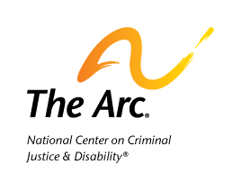 | The Arc of the United States’ National Center on Criminal Justice and Disability®  The Arc is the oldest and largest national nonprofit supporting people with intellectual and developmental disabilities (I/DD). Founded in 1950, The Arc has grown into one of the largest charity federations in the country. The Arc’s mission is to promote and protect the human rights of people with I/DD and actively support their inclusion and full participation in the community throughout their lifetimes. The Arc of the United States is The Arc’s national office. This office provides support to the 600+ chapter network and runs national initiatives that address emerging and longstanding issues in the I/DD community, including the National Center on Criminal Justice and Disability (NCCJD). Through nationwide information and referral services for individuals and families, in-person and online trainings, timely publications, and technical assistance for justice professionals, NCCJD works to increase trust and understanding between the criminal justice and disability communities.

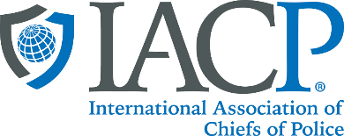 | The International Association of Chiefs of Police (IACP)  The IACP is the world’s largest and most influential professional association for police leaders. With more than 30,000 members in over 150 countries, the IACP is a recognized leader in global policing. Since 1893, the association has been speaking out on behalf of law enforcement and advancing leadership and professionalism in policing worldwide. The IACP is known for its commitment to shaping the future of the police profession. Through timely research, programming, and unparalleled training opportunities, the IACP is preparing current and emerging police leaders—and the agencies and communities they serve—to succeed in addressing the most pressing issues, threats, and challenges of the day.
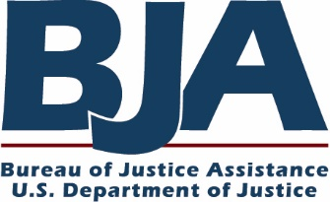 | The Bureau of Justice Assistance (BJA)  BJA provides leadership and services in grant administration and criminal justice policy development to support local, state, and tribal law enforcement in achieving safer communities. BJA supports programs and initiatives in the areas of law enforcement, justice information sharing, countering terrorism, managing offenders, combating drug crime and abuse, adjudication, advancing tribal justice, crime prevention, protecting vulnerable populations, and capacity building. Driving BJA's work in the field are the following principles:  - Emphasize local control.  - Build relationships in the field.  - Provide training and technical assistance in support of efforts to prevent crime, drug abuse, and violence at the national, state, and local levels.  - Develop collaborations and partnerships.  - Promote capacity building through planning.  - Streamline the administration of grants.  - Increase training and technical assistance.  - Create accountability of projects.  - Encourage innovation.  - Communicate the value of justice efforts to decision makers at every level.  BJA has four primary components: Policy, Programs, Operations, and the National Officer Safety and Wellness Office. The Policy Office provides national leadership in criminal justice policy, training, and technical assistance to further the administration of justice. It also acts as a liaison to national organizations that partner with BJA to set policy and help disseminate information on best and promising practices. The Programs Office coordinates and administers all state and local grant programs and acts as BJA’s direct line of communication to states, territories, and tribal governments by providing assistance and coordinating resources. The Operations Office coordinates the planning, communications, and budget functions; provides overall BJA-wide coordination; and supports streamlining efforts.

